**Experiment 3:** To Analyse Free Space and 2 Ray Propagation Models

**Name:** Jayakrishnan Menon

**Reg.no:** 22BEC1205

**Aim:**

To study the Path loss models and estimate the path loss

**Algorithm:**

1. Calculate the constant from the given values in the question.
2. Now make an array for the distance from 100 to 2000 with 100 step size.
3. Make an array of zeros with length of the array of distance.
4. Now using the formula for Path Loss and Received power calculate them using a for loop.

**Problem statement 1:**

Estimate the received power and the corresponding path loss using Free Space Propagation Model. Also plot:

1. Distance Vs. Received power and
2. Distance Vs. Path loss

Use the following values:

1. Frequency of operation = 900 MHz
2. Transmit Power = 10W
3. Gain of the transmitting antenna = 5 dB
4. Gain of the receiving antenna = 3 dB
5. Assume the system loss factor L = 1
6. Distance d = 100:100:2000 m
7. Cell radius = 500m

**Code:**

clc

clear all

close all

frequency = 900 * 1e6;

Pt = 10;

Gt = 10^(5 / 10);

Gr = 10^(3 / 10);

ht = 40;

hr = 3;

L = 1;

d = 100:100:2000;

c = 3e8;

lambda = c / frequency;

Pr = (Pt * Gt * Gr * (lambda.^2)) ./ ((4 * pi * d).^2 * L);

PL = 10 * log10(Pt ./ Pr);

figure;

subplot(2,1,1);

plot(d, Pr, 'b-', 'LineWidth', 3, 'Marker','x');

set(gca,'FontSize',20,'FontWeight','bold');

xlabel('Distance (m)');

ylabel('Received Power (W)');

title('Distance vs Received Power (Free Space)');

grid on;

subplot(2,1,2);

plot(d, PL, 'r-', 'LineWidth', 3, 'Marker','x');

set(gca,'FontSize',20,'FontWeight','bold');

xlabel('Distance (m)');

ylabel('Path Loss (dB)');

title('Distance vs Path Loss (Free Space)');

grid on;

**Output:**

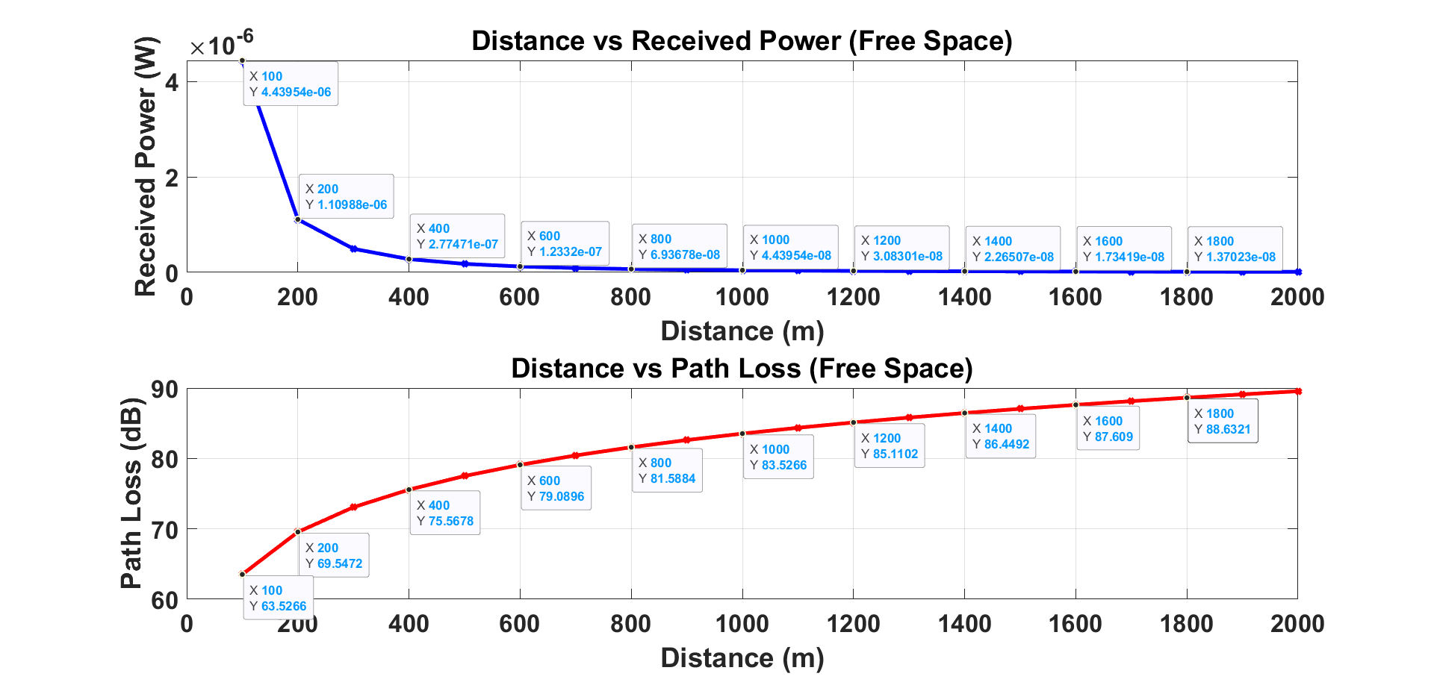

**Inference:**

1. Received Power decreases with an increase in distance
2. Path loss increases with an increase in distance

**Problem statement 2:**

Estimate the received power and the corresponding path loss using Two-ray Model. Also plot:

1. Distance Vs. Received power and
2. Distance Vs. Path loss

Use the following values:

1. Frequency of operation = 900 MHz
2. Transmit Power = 10W
3. Gain of the transmitting antenna = 5 dB
4. Gain of the receiving antenna = 3 dB
5. ht=40 m, hr = 3 m;
6. Distance d = 100:100:2000 m

**Code:**

clc

clear all

close all

frequency = 900 * 1e6;

Pt = 10;

Gt = 10^(5 / 10);

Gr = 10^(3 / 10);

ht = 40;

hr = 3;

d = 100:100:2000;

c = 3e8;

lambda = c / frequency;

Pr = (Pt * Gt * Gr * ht.^2 *hr.^2) ./ ((d).^4);

PL = 40 * log10(d)-(10*log(Gt)+10*log(Gr)+20*log(ht)+20*log(hr));

figure;

subplot(2,1,1);

plot(d, Pr, 'b-', 'LineWidth', 3, 'Marker','x');

set(gca,'FontSize',20,'FontWeight','bold');

xlabel('Distance (m)');

ylabel('Received Power (W)');

title('Distance vs Received Power (2-Ray)');

grid on;

subplot(2,1,2);

plot(d, PL, 'r-', 'LineWidth', 3, 'Marker','x');

set(gca,'FontSize',20,'FontWeight','bold');

xlabel('Distance (m)');

ylabel('Path Loss (dB)');

title('Distance vs Path Loss (2-Ray)');

grid on;

**Output:**

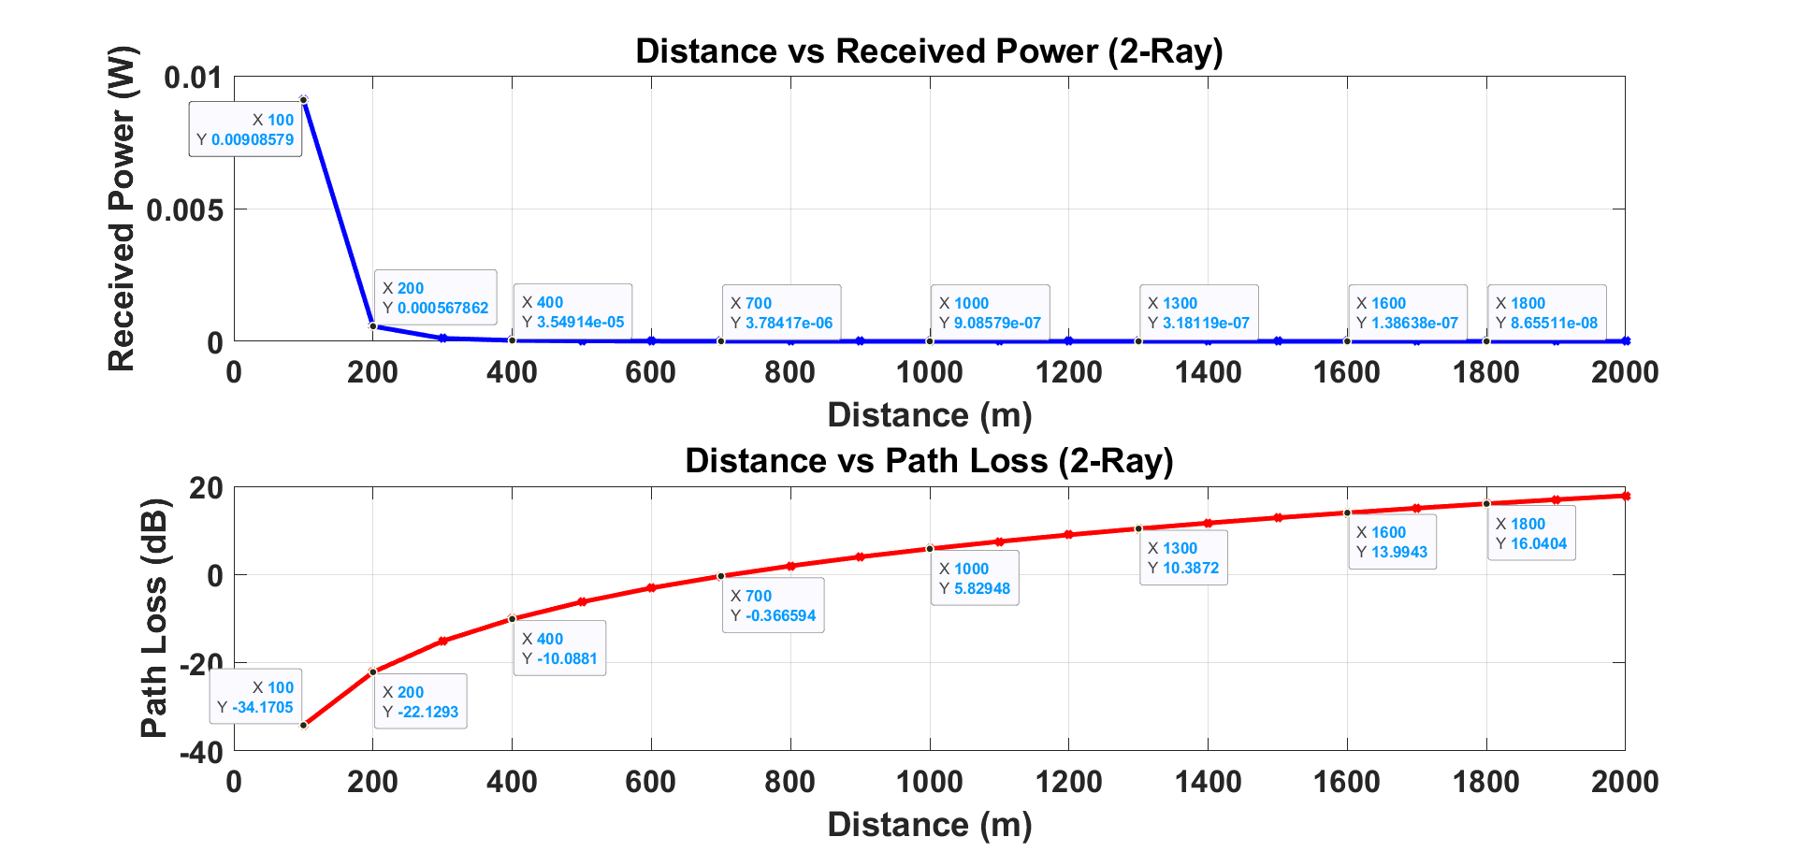 **Inference:**

1. Received Power decreases with an increase in distance
2. Path loss increases with an increase in distance

**Problem statement 3:**

C. Consider any one distance value and compare the path loss estimated using both the models.

**Code:**

clc

clear all

close all

f = 900*10^6;

pt = 10;

gt = 10^(0.5);

gr = 10^(0.3);

lamda = (3*10^8)/f;

pi = 3.14159;

L = 1;

ht = 40;

hr = 3;

d = 100:10:2000;

for i=1:length(d)

pr(i) = (pt*gt*gr*((lamda^2)/(((4*pi)^2)*L)))./(d(i)^2);

pr1(i) = (pt*gt*gr*((ht^2)*(hr^2)))/(d(i)^4);

end

pl = 10*log10(pt./pr);

pl1 = 10*log10(pt./pr1);

figure;

plot(d,pl1,'Color','#008568', 'LineWidth', 3);

hold on;

plot(d,pl,'Color','#F90046', 'LineWidth', 3);

hold off;

title('Comparing Path Loss Using Both models');

legend('2-Ray Model','Free Space Model','Location','SouthEast');

xlabel('Distance (m)','FontWeight','Bold');

ylabel('Path Loss (dB)','FontWeight','Bold');

set(gca,'FontSize',20,'FontWeight','bold');

grid on;

**Output:**

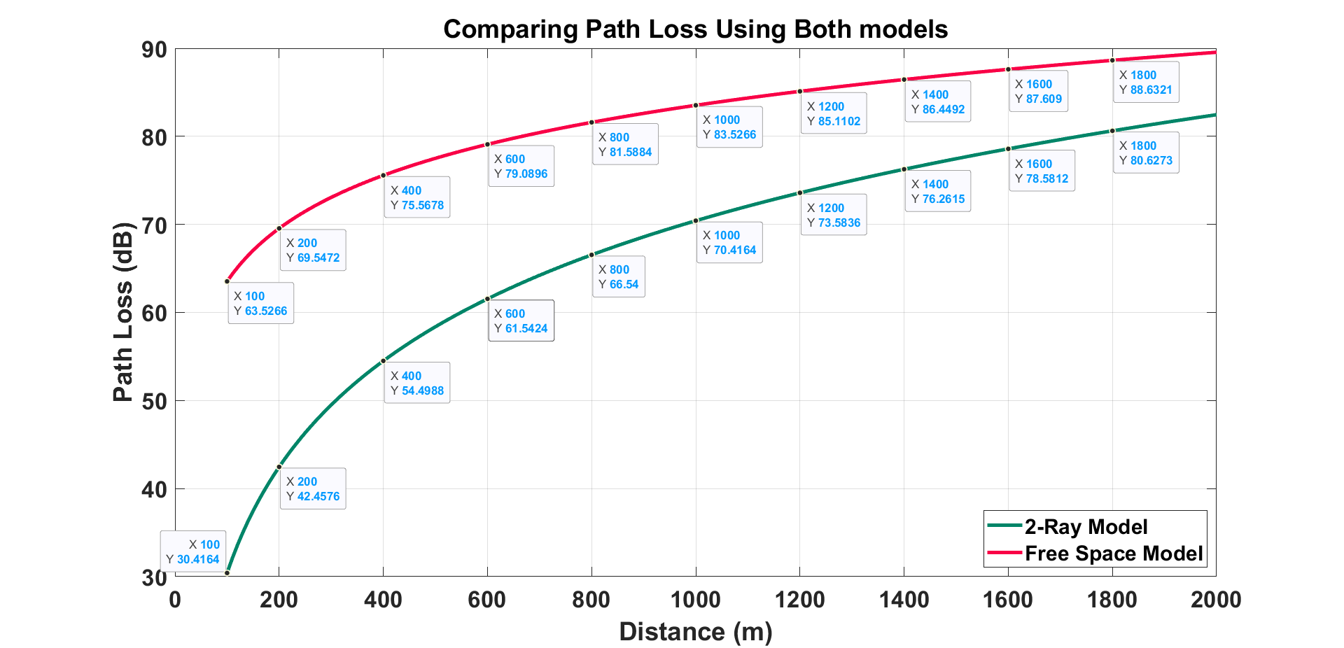 **Inference:**

Path loss for 2 Ray Model is comparatively less as compared to free space propagation model for same distance. However, for larger values of distance, the path loss values tend to come close to each other.

**Output Verification:**

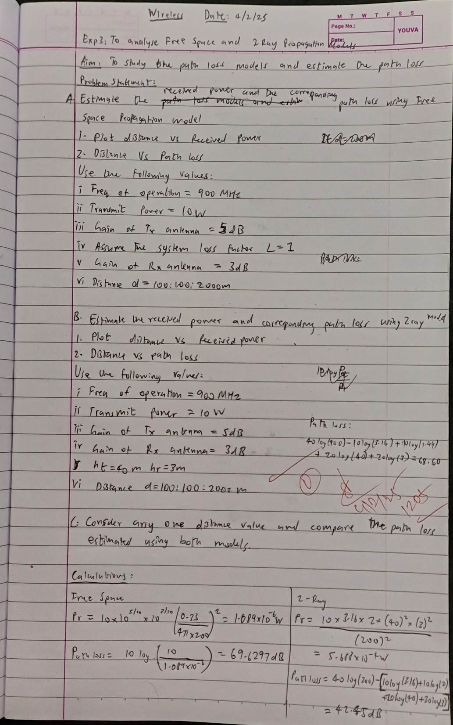

**Observation and Result:**

Hence, the graphs of received power and path loss with respect to distance were observed, calculated as well successfully and verified it with manual calculations, for the Free Space propagation model as well as the Two Ray propagation model.